Project Design Phase-II
Data Flow Diagram & User Stories

Date | 10 July 2026
Team ID
Project Name | House Rent
Maximum Marks | 4 Marks

Data Flow Diagrams:
A Data Flow Diagram (DFD) is a traditional visual representation of the information flows within a system. A neat and clear DFD can depict the right amount of the system requirement graphically. It shows how data enters and leaves the system, what changes the information, and where data is stored.
Example: DFD Level 0 (Industry Standard)
Example: (Simplified)
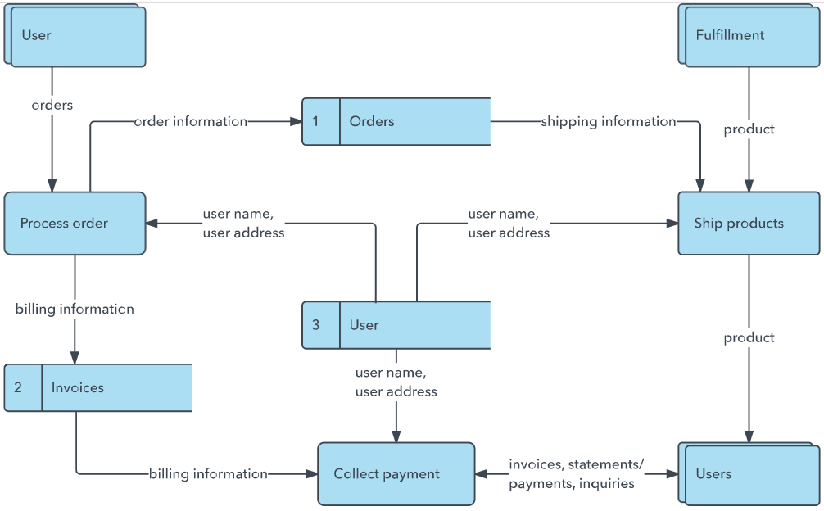


User Stories
Use the below template to list all the user stories for the product.
User Type | Functional Requirement (Epic) | User Story Number | User Story / Task | Acceptance criteria | Priority | Release
Customer (Mobile user) | Registration | USN-1 | As a user, I can register for the application by entering my email, password, and confirming my password. | I can access my account / dashboard | High | Sprint-1
 |  | USN-2 | As a user, I will receive confirmation email once I have registered for the application | I can receive confirmation email & click confirm | High | Sprint-1
 |  | USN-3 | As a user, I can register for the application through Facebook | I can register & access the dashboard with Facebook Login | Low | Sprint-2
 |  | USN-4 | As a user, I can register for the application through Gmail |  | Medium | Sprint-1
 | Login | USN-5 | As a user, I can log into the application by entering email & password |  | High | Sprint-1
Customer (Mobile user) | Dashboard | USN-6 | As a user, I can view my profile and dashboard | Dashboard is visible | High | Sprint-1
Owner | Property Listing | USN-6 | As an Owner, I can add a new property with images. | Property is visible in search results. | High | Sprint-1
Renter | Search & Filter | USN-7 | As a Renter, I can search for properties by location and price. | Filtered list of properties is displayed. | High | Sprint-1
Renter | Booking System | USN-8 | As a Renter, I can book a property for specific dates. | Booking is created in pending status. | High | Sprint-2
Owner | Manage Bookings | USN-9 | As an Owner, I can approve or reject a booking. | Booking status changes to Approved/Rejected. | High | Sprint-2
Admin | System Management | USN-10 | As an Admin, I can view all users and properties | Admin dashboard shows stats | Medium | Sprint-3
Admin | Content Management | USN-11 | As an Admin, I can block inappropriate properties | Property is hidden from search | High | Sprint-3

